Project Plan

Implementation of Power E-Commerce
for ACME Corporation

Date Created: June, 22, 2014
Last Modified: Month, day, YYYY
Prepared by: Veenayah Kunniah, Zhigang Liu, Xianling Zhao, Addison Babcock
Filename: ACME_Project_Plan_2014

© 2014 BAIST Consulting Services
All Rights Reserved
No part of this document may be reproduced, stored in a retrieval system, transmitted or displayed, in any form or by any means, including electronic, mechanical, photocopying, recording or otherwise, without the prior written permission of BAIST Consulting Services.

Confidentiality Notice:
The information in this document is the confidential information and trade secret of BAIST Consulting Services and may not be disclosed to any person without the prior written permission of BAIST Consulting Services.

STATEMENT OF CONFIDENTIALITY

The information in this document is the confidential information and trade secret of BAIST Consulting Services and may not be disclosed to any person without the prior written permission of BAIST Consulting Services.

Revision History
Version Number | Revised By | Revision Date | Summary of Changes
1. | Veenayah | June 22, 2014 | Created document.
2.
3.
4.

Table of Contents
1 Document Purpose 5
2 Executive Summary 5
3 Authorization 7
4 Project Overview 8
5 Project Approach 8
5.1 Approach 8
5.2 Stakeholders 8
6 Scope Statement 9
6.1 Recommendations 9
6.2 Major Deliverables 9
6.3 Objectives 9
7 Milestones 10
8 Assumptions 10
9 Potential Risks 10
10 Critical Assumption and Constraints 10
11 Integration Management 11
12 Scope Management 12
12.1 In Scope 12
12.2 Out of Scope 12
13 Issues Management 13
13.1 Issue Management 13
14 Time Management 14
15 Cost Management 17
15.1 Rates 17
15.2 Budget 18
16 Risk Management 19
17 Communication Management 20
18 Quality Management 22
18.1 Standards 22
18.2 Tools and Techniques 22
18.3 Completeness and Correctness Criteria 22
18.4 Quality Assurance and Control 23
19 Human Resource Management 24
19.1 Project Organization 24
19.2 Responsibility Assignment Matrix 26
19.3 Responsibility Descriptions 30
20 Procurement Management 31
21 Change Control Plan 32
22 Change Request Template 33
23 Client Acceptance Form 34
Client Acceptance Form 34
24 Transference to Operations 35
Appendix 36
Glossary of Terms 37
Acronyms 38

Document Purpose
The purpose of this project plan is to define the scope of the work required in the project and to describe how the project will be managed to meet the stated project objectives and manage the estimated costs.

Executive Summary
Today’s cartoons industry is becoming increasingly competitive for both the customers and suppliers. Customers have the power to maintain the markets whereas suppliers have the power to control the system. It is the supplier role to give information in the most effective way possible. As the years go by, the cartoons industry will become even more competitive, and the need for effective management and distribution methods will increase. The key to effective management is to get the people attention. That why we have introduced the Power E-Commerce System, a unique tool that has the power and potential to become a very effective management and distribution tool for the ACME Corporation.
The way of ordering and internal distribution provides only a minimum of satisfaction to your customers. They find it very painful and take longer to be processed compared to other suppliers. We have done some interviews with your customers regarding the service and the outcome was not very satisfactory as shown below
High | None
Medium | 30% (out of 10 customers interviewed)
Low | 70% (out of 10 customers interviewed)
The Power E-Commerce is the solution to these problems along with many others. Our product is an online system that is designed to meet your business expectations.
- Gain of new customers with Search Engine Visibility
- Lower costs in advertising, personnel and real estates.
- Locate the product quicker
- Eliminate travel Time and Cost
- Provide Comparison Shopping
- Enable Deals, Bargains, Coupons and Group Buying
- Provide Abundant Information
The implementation plan for Power E-Commerce is both cost effective and efficient. BAIST Consulting Services will be managing the project and our estimate startup time and completion of project will be approximately 12 months. Our qualified team has expertise in both technical and business process, which will ensure successful project delivery.
As the market is becoming more competitive, and are required to increase their standards, we believe that Power E-Commerce will help you in your day to day activities. We strongly believe that this will be very worthwhile to your organization as it will increase your profitability and improve your services.
Below is a flowchart of the process of Power E-Commerce
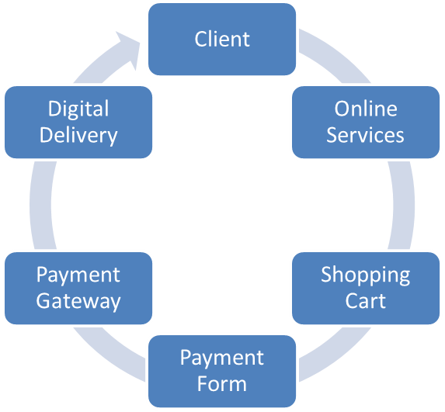

Authorization
Our signatures below signify that we have reviewed this document, and have provided authorization for work to proceed on the Implementation of Power E-Commerce as described in this document.
APPROVER | DATE
___________________________________________  [Approver Name]  [Approver Title]  [Approver Company] | ________________

APPROVER | DATE
___________________________________________  [Approver Name]  [Approver Title]  [Approver Company] | ________________

Project Overview
ACME Corporation established in 1922, is the global leader in unique tools and weapon used by cartoon villains. ACME has perfected the mail order process for distributing their products. However, with the development of e-commerce, they increasingly lose in market share due to their old ordering and internal distribution system. ACME has offices in Edmonton (HQ), testing facilities Rachel, Nevada, and manufacturing centers in Hyderabad, India and GuangMing, China. The systems within these four offices are not compatible in some case and in other cases are compatible but outdated. The goal of CEO Chuck Jones is to “have the entire organization completely connected, on a uniform platform using the latest technology.” They would like to unveil their company to the online community, make their products available anytime and anywhere. ACME would like to have a PC and Network infrastructure, Server infrastructure, Security needs, Intranet, DMZ and e-commerce solution and Web presence.

Project Approach

Approach

The Project Manager, Joe Green, has the overall authority and responsibility for managing and executing this project according to this Project Plan and its Subsidiary Management Plans. The project team will consist of personnel from the coding group, quality control/assurance group, security group, and testing group. The project manager will work with all resources to perform project planning. All project and subsidiary management plans will be reviewed and approved by the project sponsor.

Stakeholders
All funding decisions will be made by the project sponsor. Any delegation of approval authority to the project manager should be done in writing and be signed by both the project sponsor and project manager.

Scope Statement

Recommendations

With the analysis of current operation system, there are three options for AMCE:

1) Do nothing, keep current system;
2) Purchase common management software;
3) Design new specialized system using mostly existing software and hardware.

We would recommend this project because the current system can be improved significantly to benefit the company and the customers interacting with the system.

Major Deliverables
BAIST Consulting Services Deliverables:
- Implementation of hardware and software in Development, Test, and Production environments.
- Support documentation updated (Technical and Functional Requirement).
- Test plans scripts
- Security Architecture document
- Documented test results.

Client Deliverables:
- Training, documenting, and communication of any changes to business processes as a result of the changes.

Objectives
The objective is to have the entire organization connected on a uniform platform using the latest technology. They would like to unveil their company to the online community, make their products available anytime and anywhere to anyone.

Milestones
Milestones and Deliverables | Finish | Owner
Business Requirements | June 30 , 2014 | ACME/BAIST
Development work and installation | Dec 10, 2014 | BAIST
Install changes into UAT | Dec 10, 2014 | BAIST
UAT functional and security testing | Jan 30, 2015 | ACME/ BAIST
Install software into Production and hardware configuration | Feb 09, 2015 | BAIST
Completion Sign-Off | Feb 09, 2015 | ACME

Assumptions
The proposed integration may take longer than expected and the cost may increase depending on the amount of resources needed to support the project. The new system should require minimal technical support. It must be easily accessible by all the different offices.

Potential Risks

There are several risks involved with the project, such as the lack of interest in new system by company and customers and technical risks in database software. The main business risk is investing the time and money into the project and not realizing the projected benefits.

Critical Assumption and Constraints
The proposed integration may take longer than expected and the cost may increase depending on the amount of resources needed to support the project. The new system should require minimal technical support. It must be easily accessible by all the different offices.

Integration Management
The project manager will be responsible to deliver the following to the following artifacts:
- Statement of Work
- Business Case
- Maintenance Contract
- Planning Processes

Scope Management
The scope of the project includes the BAIST Consulting Services work required to implement the Power E-Commerce indicated as in-scope and verify the results. Full regression testing will be performed each time there are major changes in the application.

In Scope
The scope of this project includes the following segments of work or services:
- Design and configuration of the application and hardware to satisfy the business requirement
- Make changes as required
- Create and execute test cases to verify the functionality as expected
- Security verification in UAT and Production after the changes has been applied
- Installation and configuration of the User Testing environment
- Support User Testing and regression testing
- Installation and configuration of the production environment after client approval.
- Training of end-user
- Conversion of data

Out of Scope
The scope of this project does not include the following segments of work or services

- Major changes in the functionality of the application
- Analytics reports or customized reporting
- Upgrades of software and anti-viruses
- Penetration testing for security by a third party
- Additional hardware like high speed printers, fax

Issues Management

Issue Management
Issues on this project will be managed by maintaining an issue log specific to this project. Each issue will be numbered, dated according to the date the issue was raised, be accompanied by a description, be assigned to a specific individual for resolution and be assigned a status of open. In the event that individuals outside the direct responsibility of this project require input for resolution, those individuals will be identified as having resolution responsibility.
Issues that are identified through the usual processes of project management will be entered into the log and reviewed at each project status checkpoint. As issues age, the progress of the resolution and any decisions reached will be recorded. Once issues reach successful resolution, they will be assigned a status of closed and moved to the closed issues section of the log. Issues that require escalation through the channels of a larger project will be raised at the larger project status meetings and copied for inclusion in the large project issue log for similar management. Those issues that are raised for duplication in the larger project issue log will be noted as duplicates in both logs. From that point, progress will only be recorded in the larger project issue log until the issue is closed in both logs.

Time Management
Project schedules for the Implementation of Power E-Commerce Project will be created using MS Project 2007 starting with the deliverables identified in the project’s Work Breakdown Structure (WBS). Activity definition will identify the specific work packages which must be performed to complete each deliverable. Activity sequencing will be used to determine the order of work packages and assign relationships between project activities. Activity duration estimating will be used to calculate the number of work periods required to complete work packages. Resource estimating will be used to assign resources to work packages in order to complete schedule development.

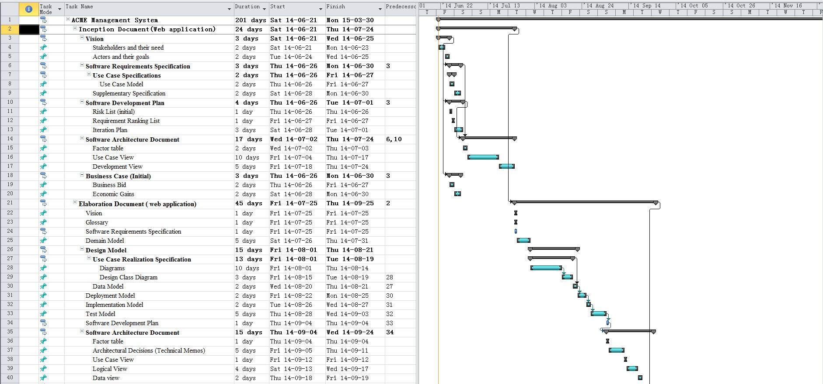
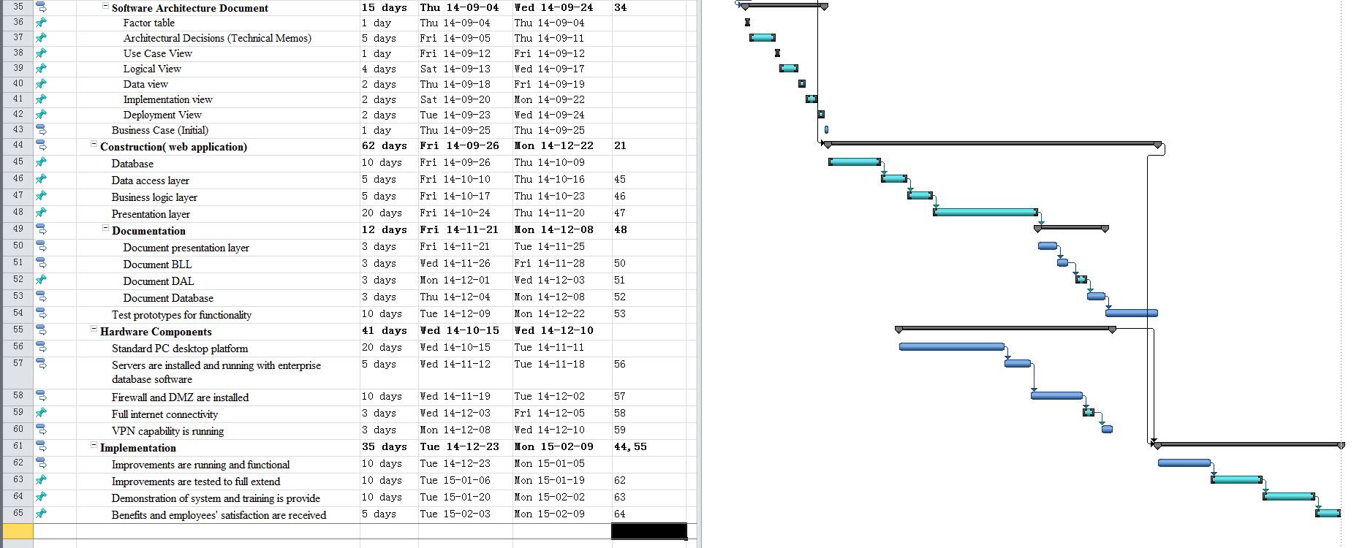

Cost Management
The Project Manager will be responsible for managing and reporting on the project’s cost throughout the duration of the project. The Project Manager will present and review the project’s cost performance during the monthly project status meeting. Using earned value calculations, the Project Manager is responsible for accounting for cost deviations and presenting the Project Sponsor with options for getting the project back on budget. All budget authority and decisions, to include budget changes, reside with the Power E-Commerce Project Sponsor.

Rates
All labour charges will be invoiced at Time and Materials Rates as per the Master Services Agreement.
All BAIST Consulting Services contractor and non-labour charges, including any project Mainframe Processing Charges, will be invoiced as a Pass-Through Expense as per the Master Services Agreement.

Budget
 | # Units/Hrs. | Cost/Unit/Hr. | Subtotals | WBS Level 1 Totals | % of Total
WBS Items
1. Project Management
1.1 Project manager | 250 | $100 | $25,000 | $103,956 | 5.35%
1.2 Project team members | 150 | $55 | $8,250
Contractors (10% of software development and testing) |  |  | $70,706
2. Hardware |  |  |  | $313,100 | 16.13%
2.1 Computers with Win 7 Pro(Dell, HP, or Lenovo) | 350 | $750 | $262,500
2.2 Gigabit Switched Ethernet | 4 | $900 | 3,600
2.3 Enterprise class firewalls | 4 | $8,500 | $34,000
2.4 DMZ | 1 | $13,000 | $13,000
3. Software |  |  |  | $757,500 | 39.03%
3.1 Licensed software | 350 | $450 | $157,500
3.2 Software development |  |  | $600,000
4. Testing (10% of total hardware and software costs) |  |  | $107,060 | $107,060 | 5.52%
5. Training and Support |  |  |  | $335,900 | 17.31%
5.1 Trainee cost | 100 | $500 | $50,000
5.2 Travel cost | 12 | $3200 | $38,400
5.3 Project team members | 4500 | $55 | $247,500
6. Reserves (20% of total estimate) | 900 |  | $347,703 | $323,503 | 16.66%
Total project cost estimate |  |  |  | $1,941,019

Risk Management
The approach for managing risks for the Power E-Commerce Project includes a methodical process by which the project team identifies, scores, and ranks the various risks. Every effort will be made to proactively identify risks ahead of time in order to implement a mitigation strategy from the project’s onset. The most likely and highest impact risks were added to the project schedule to ensure that the assigned risk managers take the necessary steps to implement the mitigation response at the appropriate time during the schedule. Risk managers will provide status updates on their assigned risks in the bi-weekly project team meetings, but only when the meetings include their risk’s planned timeframe.

Upon the completion of the project, during the closing process, the project manager will analyze each risk as well as the risk management process. Based on this analysis, the project manager will identify any improvements that can be made to the risk management process for future projects. These improvements will be captured as part of the lessons learned knowledge base.

Refer to the Appendix for the criteria used to determine assessment colours.
Risk Identification
Background
Probability Assessment | Low | Impact Assessment | High
Impact Description
Risk Response
Support Requirements

Communication Management
This Communications Management Plan sets the communications framework for this project. It will serve as a guide for communications throughout the life of the project and will be updated as communication requirements change. This plan identifies and defines the roles of Power E-Commerce project team members as they pertain to communications. It also includes a communications matrix which maps the communication requirements of this project, and communication conduct for meetings and other forms of communication. A project team directory is also included to provide contact information for all stakeholders directly involved in the project.
The Project Manager will take the lead role in ensuring effective communications on this project. The communications requirements are documented in the Communications Matrix below. The Communications Matrix will be used as the guide for what information to communicate, who is to do the communicating, when to communicate it, and to whom to communicate.
Communication Type | Description | Frequency | Format | Participants/ Distribution | Deliverable | Owner
Weekly Status Report | Email summary of project status | Weekly | Email | Project Sponsor, Team and Stakeholders | Status Report | Project Manager
Weekly Project Team Meeting | Meeting to review action register and status | Weekly | In Person | Project Team | Updated Action Register | Project Manager
Project Monthly Review (PMR) | Present metrics and status to team and sponsor | Monthly | In Person | Project Sponsor, Team, and Stakeholders | Status and Metric Presentation | Project Manager
Project Gate Reviews | Present closeout of project phases and kickoff next phase | As Needed | In Person | Project Sponsor, Team and Stakeholders | Phase completion report and phase kickoff | Project Manager
Technical Design Review | Review of any technical designs or work associated with the project | As Needed | In Person | Project Team | Technical Design Package | Project Manager

Project team directory for all communications is:
Name | Title | E mail | Office Phone | Cell Phone
John Davis | Project Sponsor | j.davis@bsa.com | xxx-xxx-xxxx | xxx-xxx-xxxx
Joe Green | Project Manager | j.green@bsa.com | xxx-xxx-xxxx | xxx-xxx-xxxx
Herb Walker | Senior Programmer | h.walker@bsa.com | xxx-xxx-xxxx | xxx-xxx-xxxx
Jason Black | Programmer | j.black@bsa.com | xxx-xxx-xxxx | xxx-xxx-xxxx
Kevin All | Programmer | k.all@bsa.com | xxx-xxx-xxxx | xxx-xxx-xxxx
Mary White | Sr. Quality Specialist | m.white@bsa.com | xxx-xxx-xxxx | xxx-xxx-xxxx
Ron Smith | Quality Specialist | r.smith@bsa.com | xxx-xxx-xxxx | xxx-xxx-xxxx
Tom Sunday | Solution Architect | t.sunday@bsa.com | xxx-xxx-xxxx | xxx-xxx-xxxx
Karen Brown | Subject Matter Expert | k.brown@bsa.com | xxx-xxx-xxxx | xxx-xxx-xxxx
Mel Joe | Sr. BA | mjoe@bsa.com | xxx-xxx-xxxx | xxx-xxx-xxxx
Paula Long | BA | plong@bsa.com | xxx-xxx-xxxx | xxx-xxx-xxxx
Lise Dean | Sr. FA | ldean@bsa.com | xxx-xxx-xxxx | xxx-xxx-xxxx
Dave Doe | FA | ddoe@bsa.com | xxx-xxx-xxxx | xxx-xxx-xxxx
Ali John | FA | ajohn@bsa.com | xxx-xxx-xxxx | xxx-xxx-xxxx
Harry Wales | Project Admin | hwales@bsa.com | xxx-xxx-xxxx | xxx-xxx-xxxx
Paul Ell | Sr. SA | pell@bsa.com | xxx-xxx-xxxx | xxx-xxx-xxxx
Cyrus Wong | SA | ldean@bsa.com | xxx-xxx-xxxx | xxx-xxx-xxxx
Dave Li | SA | dli@bsa.com | xxx-xxx-xxxx | xxx-xxx-xxxx
Leo Li | Security Expert | lli@bsa.com | xxx-xxx-xxxx | xxx-xxx-xxxx
Jen Lop | Network Admin | jlop@bsa.com | xxx-xxx-xxxx | xxx-xxx-xxxx

Quality Management
Quality on this project will be oriented toward major deliverables. Correctness and completeness criteria will be developed for each deliverable in collaboration with the individuals who will assess the quality of work. Obtaining sign off on correctness and completion criteria will signify the assessor is satisfied with quality. In the event that deliverables require significant effort to address quality and this impacts the project schedule and/or budget, the change will be managed through change control procedures.

Standards
The following testing will be performed before delivery
- Unit Testing
- User Acceptance Testing
- Regression Testing

Tools and Techniques
Test scripts will be provided for each phase of testing.

Completeness and Correctness Criteria
Below is the template for the Completeness and Correctness Criteria.
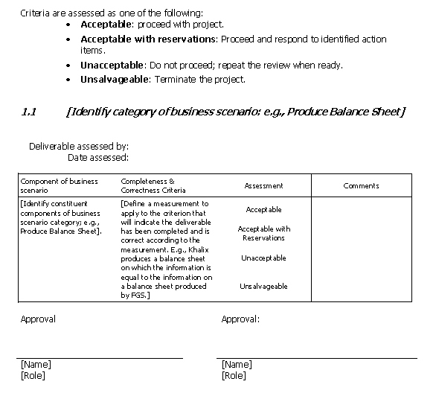

Quality Assurance and Control
The Senior Quality Assurance person will be responsible for the following activities in the project:
  - Develop user acceptance test (UAT) scenarios.
  - Run UAT test.
  - Verify UAT results.
  - Obtain client sign off for the UAT results.

Human Resource Management

Project Organization

The team will consist of the following
Job Title | Number
Project Manager | 1
Project Administrator | 1
Business Analyst | 2
Functional Analyst | 3
System Analyst | 2
Programmer | 3
Solution Architect | 1
SME (Subject Matter Expert) | 1
Security Expert | 1
Network Administrator | 1

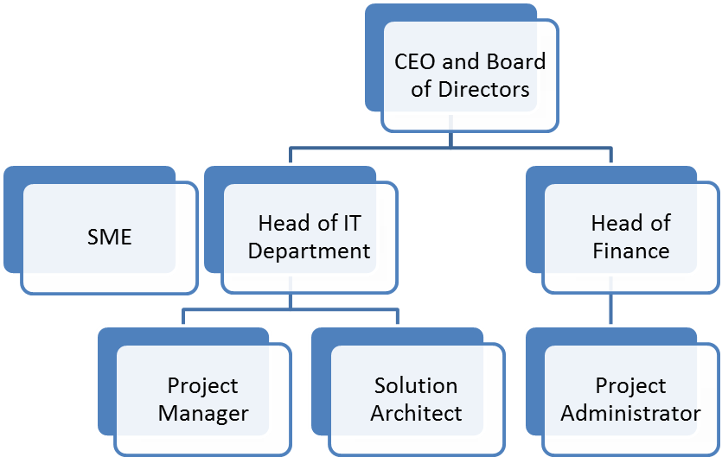

2
Business Analysts
2
Functional Analysts
2
System Analysts
3 Programmers
1
Network Administrator

2
Quality Assurance

Responsibility Assignment Matrix
 | ACME Corporation
WBS Activities | PM | BA | FA | SA | Prgrammer | Network Admin | Solution Architecture | Quality Assurance | Security Expert
1. Inception document ( web application)
1.1. Vision | X
1.1.1. Stakeholders and their need
1.1.2. Actors and their goals
1.2. Software Requirements Specification | X
1.2.1. Use Case Specifications
1.2.1.1. Use Case Model
1.2.2. Supplementary Specification
1.3. Software Development Plan | X
1.3.1. Risk List (initial)
1.3.2. Requirement Ranking List
1.3.3. Iteration Plan
1.4. Software Architecture Document |  |  |  |  |  |  | X
1.4.1. Factor table
1.4.2. Use Case View
1.4.3. Development View
1.5. Business Case (Initial) | X
1.5.1. Business Bid
1.5.2. Economic Gains
2. Elaboration Document ( web application)
2.1. Vision |  | X
2.2. Glossary |  | X
2.3. Software Requirements Specification |  | X
2.4. Domain Model |  | X
2.5. Design Model |  |  |  | X
2.5.1. Use Case Realization Specification
2.5.1.1. Diagrams
2.5.1.2. Design Class Diagram
2.5.2. Data Model |  |  | X
2.6. Deployment Model |  |  | X
2.7. Implementation Model |  |  |  |  |  |  |  | X
2.8. Test Model |  |  |  |  |  |  |  | X
2.9. Software Development Plan |  |  |  |  | X
2.10. Software Architecture Document |  |  |  |  | X | X | X |  | X
2.10.1. Factor table
2.10.2. Architectural Decisions (Technical Memos)
2.10.3. Use Case View
2.10.4. Logical View
2.10.5. Data view
2.10.6. Implementation view
2.10.7. Deployment View
2.11. Business Case (Initial) |  | X | X
3. Construction( web application) |  |  |  |  | X |  |  |  | X
3.1. Presentation layer
3.2. Business logic layer
3.3. Data access layer
3.4. Database
3.5. Documentation
3.5.1. Document presentation layer
3.5.2. Document BLL
3.5.3. Document DAL
3.5.4. Document Database
3.6. Test prototypes for functionality
4. Hardware Components |  |  |  |  |  | X | X |  | X
4.1. Standard PC desktop platform
4.2. Servers are installed and running with enterprise database software
4.3. Firewall and DMZ are installed
4.4. VPN capability is running
4.5. Full internet connectivity
5. Implementation | X | X | X |  |  |  |  | X
5.1. Improvements are running and functional
5.2. Improvements are tested to full extend
5.3. Demonstration of system and training is provide
5.4. Benefits and employees' satisfaction are received

Responsibility Descriptions
Role | Responsibilities | Name
PMO | - Monitors progress of project  - Assesses project success  - Provides direction & guidance  - Facilitates problem-solving & dissemination of information as required  - Reviews project management deliverables | Joe Green

Procurement Management
The Project Manager will provide oversight and management for all procurement activities under this project. The Project Manager is authorized to approve all procurement actions up to $50,000. Any procurement actions exceeding this amount must be approved by the CEO of the company.
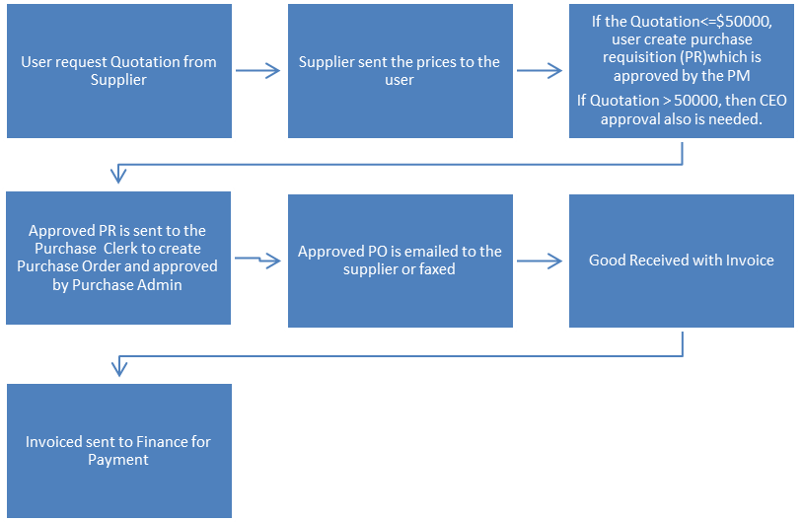

In the event a procurement becomes necessary, the Project Manager will be responsible for management any selected vendor or external resource. The Project Manager will also measure performance as it relates to the vendor providing necessary goods and/or services and communicate this to the purchasing and contracts groups.

Change Control Plan
Requests for changes or additions to the project particulars identified in this document, originating from either the project team or key project stakeholders, will be implemented once those changes have been approved and agreed to by the project manager and the key client. Using BAIST Consulting Services’s Project Change Control process, each request will be considered based on the following criteria:
- The perceived value of the request within the context of the entire project and its business implications
- The effect of the change on the entire project
- An assessment of any issues and risks associated with the request
Approval of changes or additions to the project will be facilitated through a Project Change Addendum. The Project Change Addendum addends the approved Project Plan or Statement of Work and supersedes all terms that are consistent with a term or provision contained in the Project Plan or Statement of Work. Once a Project Change Addendum is approved, the Project Manager will adjust the project schedule or other supporting project documents as required and work will proceed.

Change Request Template
Change Request Form

Project Name: Implementation of Power E-Commerce
Date Request Submitted:
Title of Change Request
Change Order Number:
Submitted by: (name and contact information)
Change Category: Scope Schedule Cost Technology Other

Description of change requested:

Events that made this change necessary or desirable:

Justification for the change/why it is needed/desired to continue/complete the project:

Impact of the proposed change on:
Scope:
Schedule:
Cost:
Staffing:
Risk:
Other:

Suggested implementation if the change request is approved:

Required approvals:
Name/Title | Date | Approve/Reject

Client Acceptance Form

Client Acceptance Form

Client Acceptance/Project Completion Form

Project Name: Implementation of Power E-Commerce
Project Manager: Joe Green

I (We), the undersigned, acknowledge and accept delivery of the work completed for this project on behalf of our organization. My (Our) signature(s) attest to my (our) agreement that this project has been completed. No further work should be done on this project.

Name | Title | Signature | Date
Chuck Jones | CEO

- Was this project completed to your satisfaction? Yes No

- Please provide the main reasons for your satisfaction or dissatisfaction with this project.

- Please provide suggestions on how our organization could improve its project delivery capability in the future.

Thank you for your inputs.

Transference to Operations
The post implementation support period for this work is 10 elapsed days from the production migration date with an estimated maximum expenditure of $25,000. Additional charges may apply depending on the support required. If this is the case, the BAIS Consulting Services will request approval from the ACME Corporation before proceeding.
Once the post implementation period has elapsed, we will send you the Service Agreement for one year with the number of hours and prices. If all conditions are accepted, the document has to be sign by ACME Corporation and email to the PMO office. If they do not agree to the conditions, then no support will be provided to the users.
Process to request service from BAIST Consulting Services
- Log into BAIST Consulting Services Helpdesk Tools and log a ticket
- User will receive email to notify that someone will call on the next “X” hours depending on the ticket priority
Priority | Response Time
High | Next 2 hours
Medium | 8 hours
Low | 1 day
- Someone from the HelpDesk will call you or send email to solve the problem.

Appendix
Risk Assessment Criteria
The legend below is used when assessing the probability of the risk occurring:
Low | A green flag indicates the risk has a low probability of occurring.
Medium | A yellow flag indicates a 0.5 probability of occurring.
High | A red flag indicates the risk has a high probability of occurring.

The legend below is used when assessing the impact the risk will have on the successful outcome of the project:
Low | A green flag indicates minimal impact to one or more project performance baselines (i.e. cost, schedule, scope or quality), if the risk occurs. A green flag also indicates the project can tolerate the risk.
Medium | A yellow flag indicates a medium impact to one or more project performance baselines (i.e. cost, schedule, scope or quality), if the risk occurs. The project manager has concerns over whether the project can tolerate the risk.
High | A red flag indicates a high impact to one or more project performance baselines (i.e. cost, schedule, scope or quality), if the risk occurs. The project manager is certain the project cannot tolerate the risk.

Glossary of Terms

Business case:
Provides reasoning for initiating a project.
Scope Statement:
The Scope Statement describes the scope of the project. It should be high-level but kept accurate.
Work Breakdown Structure:
Project is broken down into smaller pars so tasks can be assigned and the project can be managed as a whole.
Gantt Chart:
A Gantt chart, commonly used in project management, is one of the most popular and useful ways of showing activities (tasks or events) displayed against time.
Communication management Plan:
The Communications Plan describes how communications will be carried out over the course of the project.
Quality Management Plan:
The Quality Management Plan defines the acceptable level of quality, which is typically defined by the customer, and describes how the project will ensure this level of quality in its deliverables and work processes.
Change Control Plan:
The Change Control Plan describes how the Integrated Change Control process works and who is involved.
Risk Management Plan:
The Risk Management Plan describes how risks will be managed throughout the project.
Project Manager:
The person who oversees the project and is the main person that controls all areas of the project.
Deliverable:
A tangible or intangible object that is produced as a result of developing and completing tasks that are assigned.

Acronyms
PMR | Project Monthly Review
PMO | Project Management Office
PR | Purchase Requisition
SME | Subject Matter Expert
BA | Business Analyst
FA | Functional Analyst
SA | System Analyst
QA | Quality Assurance
PO | Purchase Order
Project Admin | Project Administrator
Network Admin | Network Administrator
SR. | Senior
UAT | User Acceptance Testing

